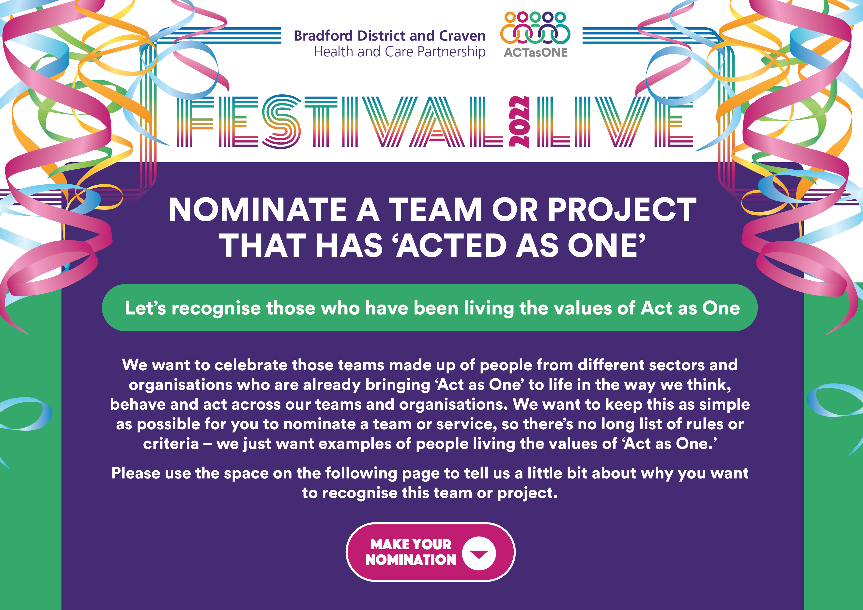

NOMINATION FORM

Your name: | Your Twitter handle (if you have one and don’t mind sharing):
Your contact details: | Who are you nominating to be recognised?
Tell us, in no more than 250 words, why you are nominating this team or project:

Please get your nomination back to us by 5pm on Monday 18 July by email to kate.harrison16@nhs.net

We’ll be in touch with more details about the Recognition Day and how you can join us.

